LES PTO General Meeting Minutes
9/14/2020

Meeting Called to Order by Tracy Sanderson at 8:00pm
Quorum Established
Parliamentarian appointed – Kasey Havens
Introductions

Treasurer Report- Chantell presented by Barbara Farris
- Barbara reviewed 2020/21 budget. Screenshot shared below.
- Tracy informed everyone the large carryover was due to Covid hitting in the spring and several programs were cancelled.
- 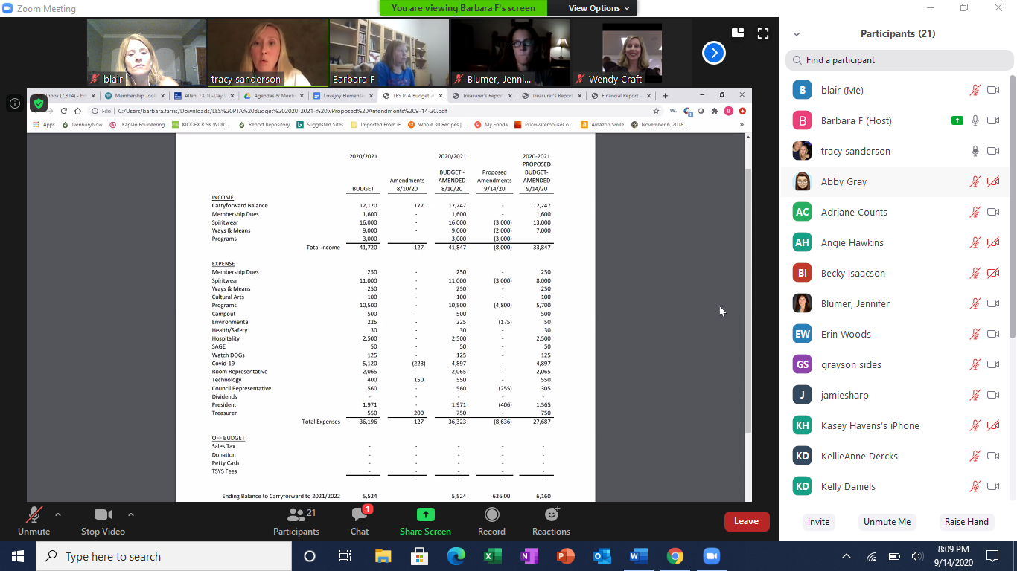
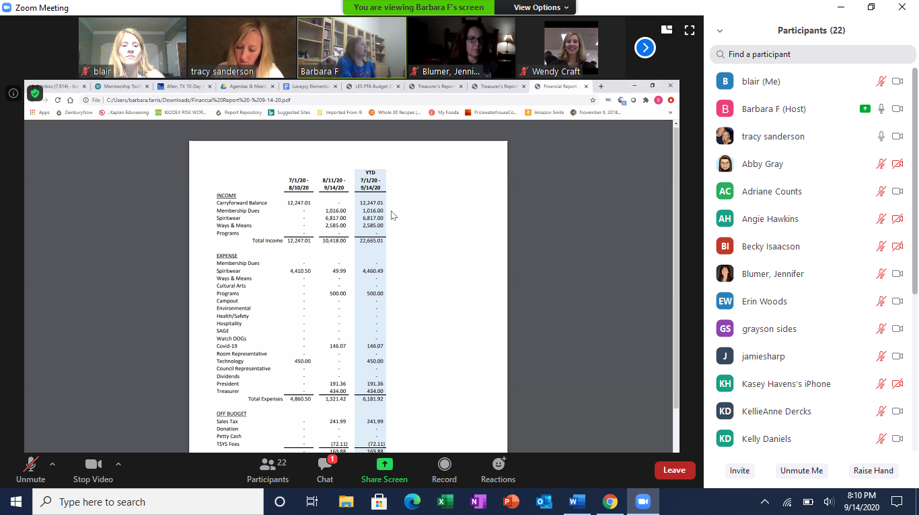
President Report- Tracy Sanderson
- Welcome and thank you for coming
- We moved from a PTA last year and this is our first year as a PTO
- We have adopted a new technology platform
- Our 3 goals for the year are connect, enrich and advocate
- Fundraising will look very different this year

Principal – Mrs. Craft
- Thank you for the welcome back signs, staff meal and Dennis Lee
- Designing a virtual Leopard Live
- Kicking of kindness program that will be continued from last year
- Drop off and pick-up are going great
- Window is open to select school (virtual or on-campus) for the next 9 weeks

Programs – Kelly Daniels
- Dennis Lee went well
- Red ribbon week is coming up in Oct. Will have a virtual speaker for the end of that week. More details to come

Ways and Means – KellieAnne Dercks
- Sprit night will be Set. 16 at Raising Canes
- Working on details for a raffle for a carline spot
- Will start recruiting for help with Paw signs
- $2,000 is the current total for Leopard Drive

Membership-Barbara Farris
- Total membership is 140
- Website works better on computer, some issues have come up when trying to join on the phone

Technology – Tera Chavez
- Demo of new website and all the features

Spiritwear – Jami Sharp
- $7,000 in sales, spiritwear is going well
- Fundraiser to purchase a t-shirt for the teachers, waiting on design
- Tax free days are Sept. 28 and Nov. 6

Hospitality – Abby Gray
- Provided lunch for the teachers from ChopHouse for the first day of school
- Had great participation (40-50) signs that were put out for the teachers on the first day

Volunteer Coordinator – Adriane Counts
- Highlighted volunteer page and needs that will be listed
- Reminder to fill out page that the district provides to be approved to volunteer on campus
- Current needs are spiritwear delivery and Paw Sign delivery

New Business
Tera Chavez presented financial reconciliation report signed off on Aug. 9. Report is included in binder as an attachment for all details.

Tera makes a motion to adopt the financial reconciliation as presented. KellieAnne Dercks seconds the motion. Motion carries.

Anna Sides makes a motion to adopt 2020-21 amended budget as presented. Reagan Mosty seconds the motion. Motion carries

We will be using new online payment collection systems (TTYS for membership toolkit and Square for in-person spirit wear sales.

Tina Fast makes a motion to adopt TYTS for membership toolkit as well as the Square. Abby Gray seconds the motion. Motion carries.

Anna Sides makes a motion to approve the following fundraisers for the 2020-21 school year (Leopard Drive, PAW Signs, Spirit Nights, Carline raffles/auction. KelliAnne Dercks seconds the motion. The motion carries.

Kelly Daniels makes a motion to adopt Sept. 28 and Nov.6 as our two tax free days. Jamie Sharp seconds the motion. Motion carries.

Review of Important Dates – upcoming superintendent meetings

Meeting Adjourn at 8:41

Meeting Attendees captured below
